**Computing – Year 1**

Digital Imagery

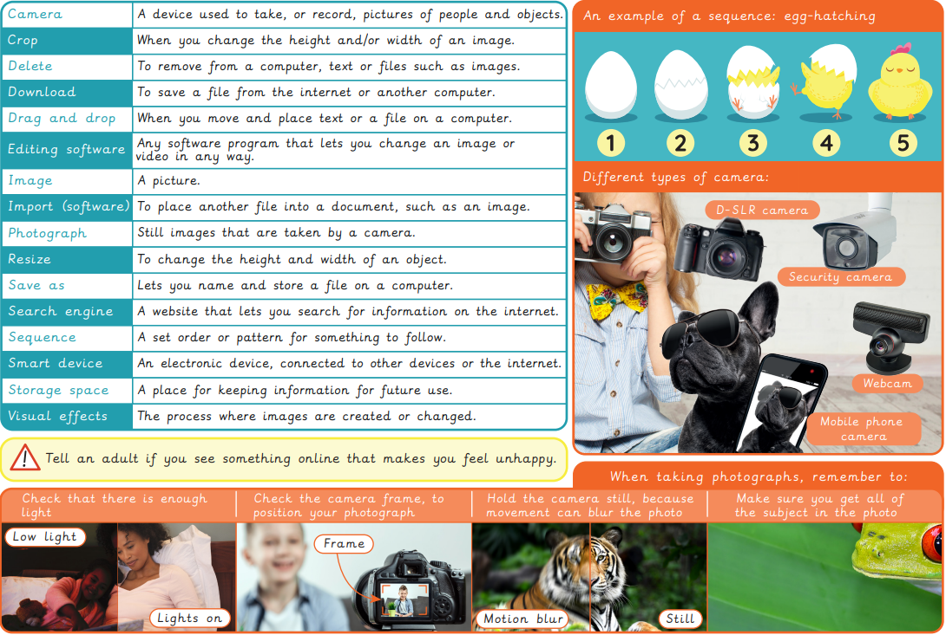

|  |  |  |  |  |
| --- | --- | --- | --- | --- |
| **Sticky Knowledge** | | | | |
| * To understand that holding the camera or device still and considering angles and light are important to take good pictures. * To know that you can edit, crop and filter photographs. * To know how to search safely for images online. | | | | |
| **Vocabulary words I know** | | | | |
| background | blurred | camera | clear | crop |
| delete | device | digital camera | download | drag and drop |
| edit | editing software | filter | image | import |
| internet | keyword | online | photograph | resize |
| save as | screen | search engine | sequence | software |
| storage space | visual effects |  |  |  |
| I don’t know it I know what it means I can use it in a sentence | | | | |