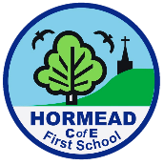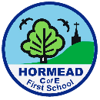**Computing – Year 3/4**

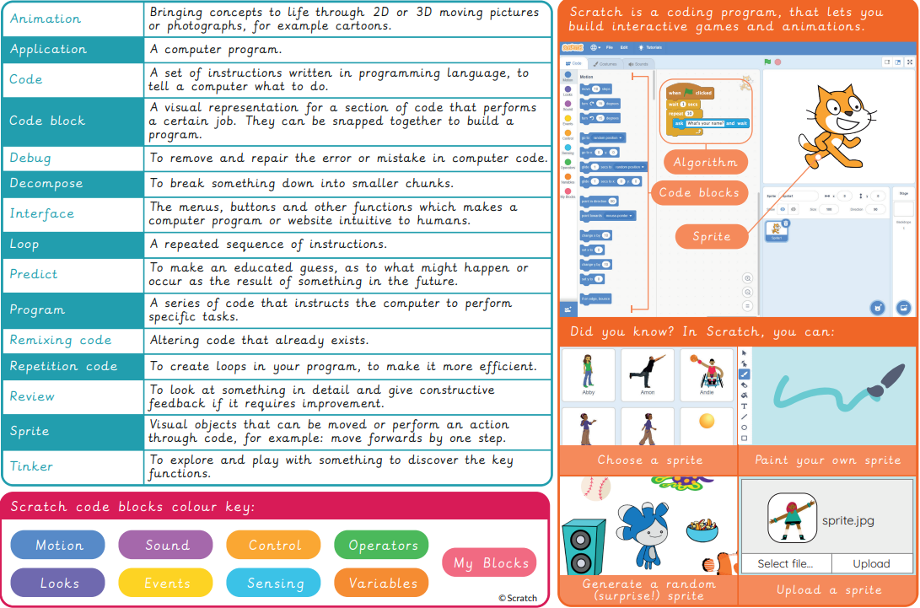Programming - Scratch

|  |  |  |  |  |
| --- | --- | --- | --- | --- |
| **Sticky Knowledge** | | | | |
| * Scratch is a programming language and some of its basic functions. * How to use loops to improve programming. * **How decomposition is used in programming.** * That you can remix and adapt existing code. | | | | |
| **Vocabulary words I know** | | | | |
| algorithm | animation | application | code | code block |
| debug | decompose | game | interface | loop |
| predict | program | remixing code | repetition code | review |
| Scratch | sprite tinker |  |  |  |
| I don’t know it I know what it means I can use it in a sentence | | | | |